**Assignment: Tribute Page**

**(CDS BIPIN RAWAT)**

**Name: Jogdand Abhishek Chandrasen**

**Mob no: 9325496292**

**Mail id:** [**cdt.abhijogdand447@gmail.com**](mailto:cdt.abhijogdand447@gmail.com)

**Output:**

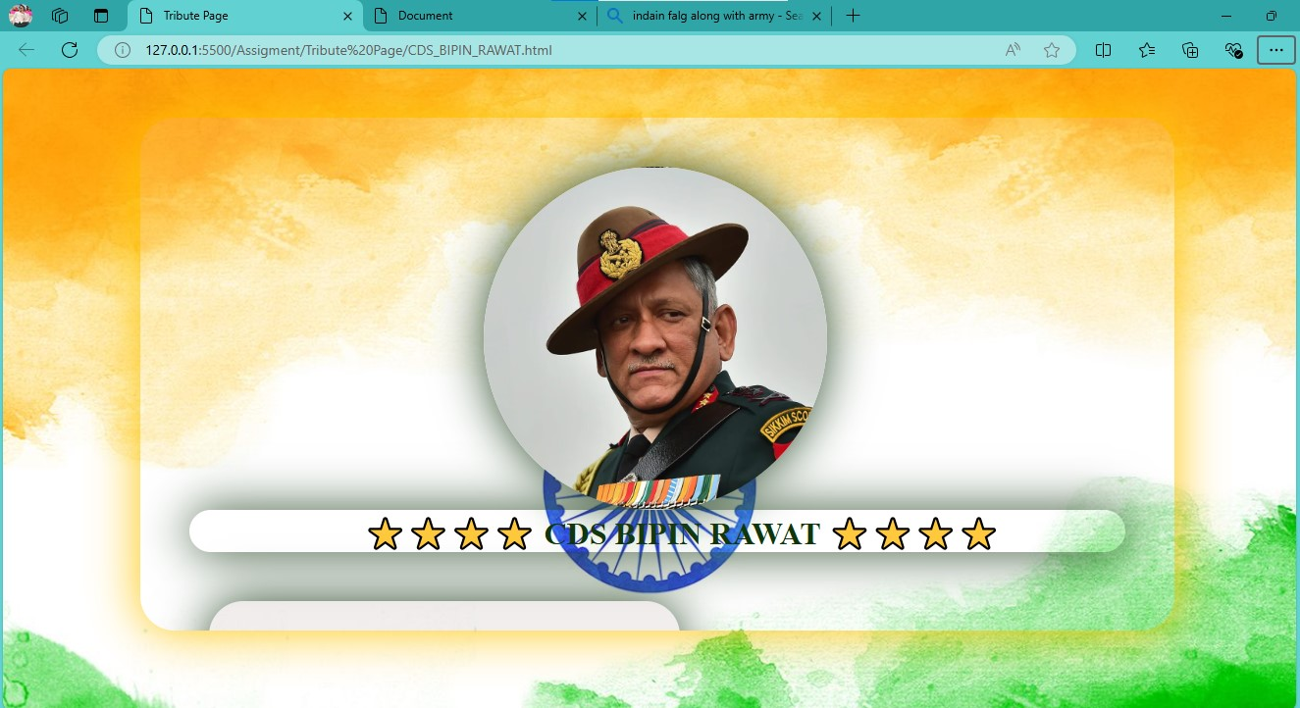

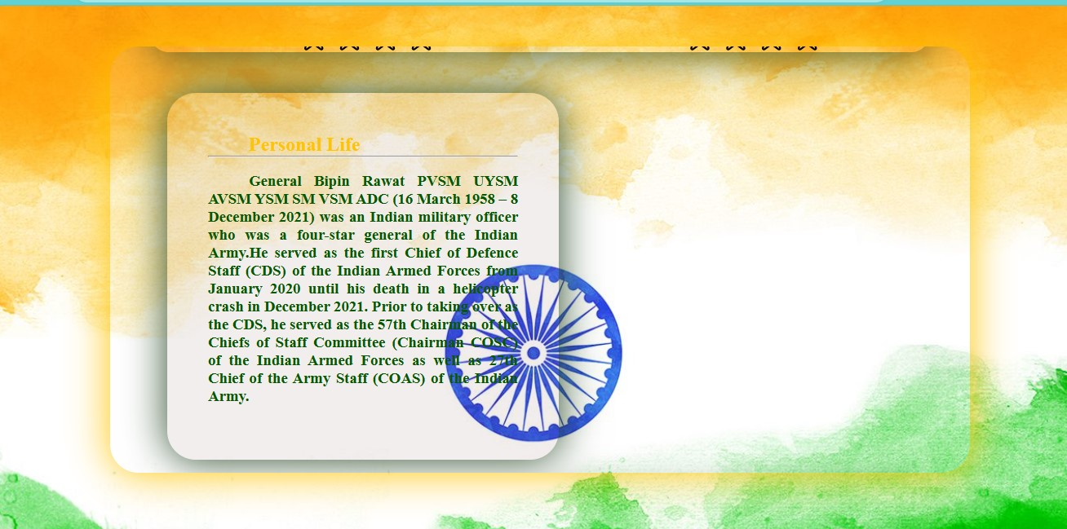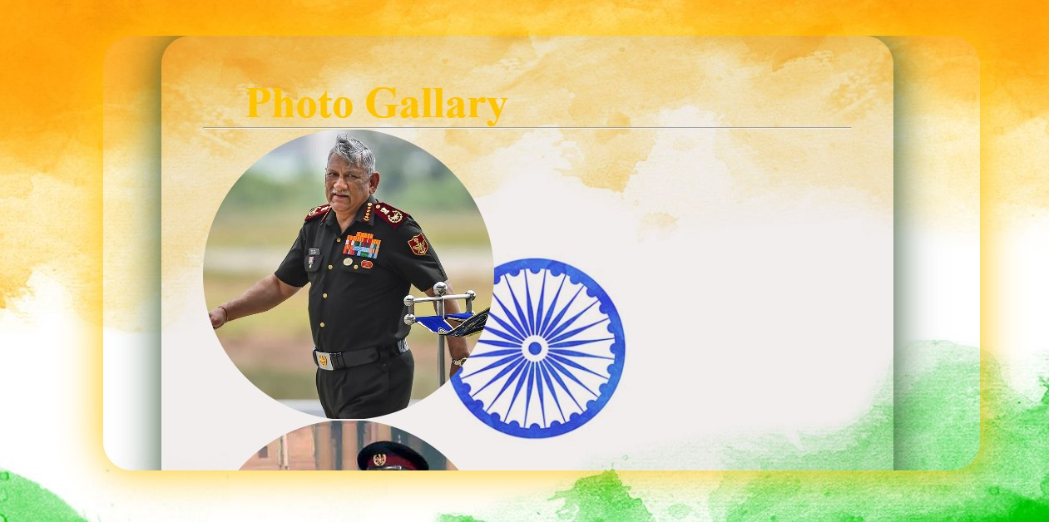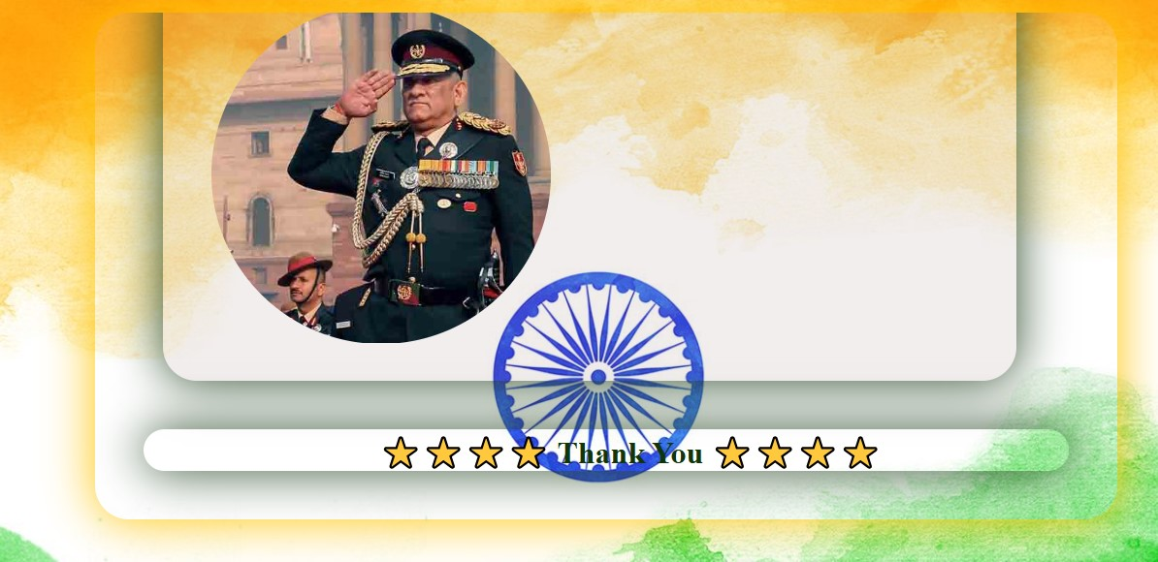

**Code for tribute_page.html**

**<!DOCTYPE html>**

**<html lang="en">**

**<head>**

**<meta charset="UTF-8">**

**<meta name="viewport" content="width=device-width, initial-scale=1.0">**

**<title>Tribute Page</title>**

**<style>**

**\* {**

**padding: 0px;**

**margin: 0px;**

**box-sizing: border-box;**

**}**

**body {**

**height: 100%;**

**width: 100%;**

**background-image: url("./flag\ 3.jpg");**

**/* background-image: url("./bg\ 2.jpg"); */**

**/* background-image: url("./bg\ 1.jpg"); */**

**/* background-image: url("./army.jpg"); */**

**background-repeat: no-repeat;**

**background-size: cover;**

**background-color: rgba(255, 255, 255, 0.33);**

**/* box-shadow: 0px 0px 50px rgb(42, 73, 40); */**

**}**

**.container {**

**width: 100%;**

**height: 100vh;**

**border: 1px solid;**

**/* background-image: url("./bg\ 1.jpg");**

**background-repeat: no-repeat;**

**background-size: cover; */**

**}**

**#container1 {**

**height: 80vh;**

**width: 80vw;**

**padding: 50px;**

**margin: 50px;**

**margin-left: 140px;**

**box-shadow: 0px 0px 50px;**

**border: 1px transparent;**

**border-radius: 35px;**

**background-color: skyblue;**

**position: relative;**

**background-color: rgba(255, 255, 255, 0.13);**

**overflow: scroll;**

**color: rgb(255, 196, 0);**

**text-indent: 50px;**

**text-align: center;**

**text-align: justify;**

**/* padding: 50px; */**

**/* z-index: -1; */**

**border: hidden;**

**scrollbar-width: none;**

**}**

**.photo {**

**height: 350px;**

**width: 350px;**

**border-radius: 50%;**

**/* align-items: center; */**

**/* left: 30px auto; */**

**background-image: url("./cds\ 2.avif");**

**background-size: cover;**

**/* padding: 100px; */**

**left: 300px;**

**background-position: center;**

**border: 1px solid transparent;**

**box-shadow: 0px 0px 50px rgb(42, 73, 40);**

**position: relative;**

**/* animation: slider infinite 3s linear; */**

**}**

**.name {**

**color: rgb(16, 53, 11);**

**text-indent: 50px;**

**border-radius: 50px;**

**text-decoration: dashed;**

**box-shadow: 0px 0px 50px rgb(42, 73, 40);**

**text-align: center;**

**}**

**.datacontainer {**

**height: 450px;**

**width: 480px;**

**padding: 50px;**

**margin: 50px;**

**margin-left: 20px;**

**box-shadow: 0px 0px 50px;**

**border: 1px transparent;**

**border-radius: 35px;**

**position: relative;**

**background-color: rgba(128, 87, 87, 0.1);**

**/* overflow: scroll; */**

**color: rgb(42, 73, 40);**

**text-indent: 50px;**

**text-align: center;**

**text-align: justify;**

**border: hidden;**

**scrollbar-width: none;**

**text-indent: 50px;**

**text-decoration: dashed;**

**box-shadow: 0px 0px 50px rgb(42, 73, 40);**

**}**

**#data1 {**

**left: 0px;**

**}**

**#data2 {**

**left: 450px;**

**}**

**#data3 {**

**left: 0px;**

**}**

**#data4 {**

**left: 450px;**

**}**

**#data5 {**

**left: 0px;**

**}**

**#data6 {**

**left: 450px;**

**}**

**#data7 {**

**left: 0px;**

**}**

**#data8 {**

**left: 450px;**

**}**

**#data9 {**

**left: 0px;**

**}**

**#data10 {**

**left: 450px;**

**}**

**#data11 {**

**left: 0px;**

**}**

**#data12 {**

**left: 450px;**

**}**

**#data13 {**

**left: 0px;**

**}**

**#data14 {**

**left: 450px;**

**}**

**#data15 {**

**left: 0px;**

**height: 660px;**

**width: 880px;**

**}**

**#data16 {**

**height: 850px;**

**width: 880px;**

**font-size: 35px;**

**}**

**/* .photocontainer{**

**height: 100px;**

**width: 100px;**

**border: 1px solid;**

**text-align: center;**

**line-height: 100px;**

**display: inline-block;**

**text-shadow: 15px;**

**} */**

**#photo1 {**

**height: 350px;**

**width: 350px;**

**background-image: url("./cds\ 7.jpg");**

**background-repeat: no-repeat;**

**background-size: cover;**

**background-position: center;**

**border-radius: 50%;**

**border: 1px solid transparent;**

**padding: 20px;**

**}**

**#photo2 {**

**height: 350px;**

**width: 350px;**

**background-image: url("./cds\ 6.jpg");**

**background-repeat: no-repeat;**

**background-size: cover;**

**background-position: center;**

**border-radius: 50%;**

**border: 1px solid transparent;**

**padding: 20px;**

**}**

**/* #photo3 {**

**height: 350px;**

**width: 350px;**

**left: 400px;**

**position: absolute;**

**background-image: url("./cds\ 7.jpg");**

**background-repeat: no-repeat;**

**background-size: cover;**

**background-position: center;**

**border-radius: 50%;**

**border: 1px solid transparent;**

**padding: 20px;**

**}**

**#photo4 {**

**height: 350px;**

**width: 350px;**

**left: 400px;**

**position: absolute;**

**background-image: url("./cds\ 7.jpg");**

**background-repeat: no-repeat;**

**background-size: cover;**

**background-position: center;**

**border-radius: 50%;**

**border: 1px solid transparent;**

**padding: 20px;**

**} */**

**.thanks {**

**color: rgb(16, 53, 11);**

**text-indent: 50px;**

**border-radius: 50px;**

**text-decoration: dashed;**

**box-shadow: 0px 0px 50px rgb(42, 73, 40);**

**text-align: center;**

**}**

**h2 {**

**color: rgb(255, 196, 0);**

**}**

**h3 {**

**color: rgb(8, 88, 3);**

**}**

**</style>**

**</head>**

**<body>**

**<div class="container" id="container1">**

**<div class="photo" id="contain">**

**</h1>**

**</div>**

**<div class="name">**

**<h1 class="title">⭐️⭐️⭐️⭐️ CDS BIPIN RAWAT ⭐️⭐️⭐️⭐️</h1>**

**</div>**

**<div class="datacontainer" id="data1">**

**<h2><b>Personal Life**

**<hr>**

**</b></h2>**

**<br>**

**<h3>General Bipin Rawat PVSM UYSM AVSM YSM SM VSM ADC (16 March 1958 – 8 December 2021) was an Indian**

**military officer who was a four-star general of the Indian Army.He served as the first Chief of**

**Defence Staff (CDS) of the Indian Armed Forces from January 2020 until his death in a helicopter**

**crash in December 2021. Prior to taking over as the CDS, he served as the 57th Chairman of the**

**Chiefs of Staff Committee (Chairman COSC) of the Indian Armed Forces as well as 27th Chief of the**

**Army Staff (COAS) of the Indian Army.**

**</h3>**

**</div>**

**<div class="datacontainer" id="data2">**

**<h2><b>Early life and education!!**

**<hr>**

**</b></h2>**

**<br>**

**<h3>Bipin Rawat was born in Pauri town of Pauri Garhwal district, present-day Uttarakhand state, on 16 March**

**1958 [8] to a Hindu Garhwali Rajput family. His family had been serving in the Indian Army for**

**multiple generations. His father Lakshman Singh Rawat (1930–2015) was from Sainj village of the Pauri**

**Garhwal district; commissioned into 3/11 Gorkha Rifles in 1951, he retired as Deputy Chief of the Army**

**Staff in 1988 as a Lieutenant General. His mother was from the Uttarkashi district and was**

**the daughter of Kishan Singh Parmar, the ex-Member of the Legislative Assembly (MLA) from Uttarkashi.**

**</h3>**

**</div>**

**<!-- 3ed box -->**

**<div class="datacontainer" id="data3">**

**<h2><b>Early life and education!!**

**<hr>**

**</b></h2>**

**<br>**

**<h3>Rawat was also a graduate of the Defence Services Staff College (DSSC), Wellington and the Higher**

**Command Course at the United States Army Command and General Staff College (USACGSC) at Fort**

**Leavenworth, Kansas in 1997. From his tenure at the DSSC, he obtained an MPhil degree in**

**Defence Studies as well as diplomas in Management and Computer Studies from the University of Madras. In**

**2011, he was awarded an honorary doctorate by Chaudhary Charan Singh University, Meerut for his research**

**on military-media strategic studies.**

**</h3>**

**</div>**

**<!-- 4th box -->**

**<div class="datacontainer" id="data4">**

**<h2><b>Military career**

**<hr>**

**<hr><br>Early career**

**</b></h2>**

**<br>**

**<h3>Rawat was commissioned into the 5th battalion, the 11 Gorkha Rifles (5/11 GR) on 16 December 1978, the**

**same unit as his father.[21][22] During the 1987 Sino-Indian skirmish in the Sumdorong Chu valley, then**

**Captain Rawat's battalion was deployed against the Chinese People's Liberation Army.[23] The standoff**

**was the first military confrontation along the disputed McMahon Line after the 1962 war**

**</h3>**

**</div>**

**<!-- box 5 -->**

**<div class="datacontainer" id="data5">**

**<h2><b>Military career**

**<hr>**

**</b></h2>**

**<br>**

**<h3> Early in his career, Rawat had an instructional tenure at the Indian Military Academy, Dehradun. He had**

**much experience in high-altitude warfare and spent ten years conducting counter-insurgency**

**operations.[18] He commanded a company in Uri, Jammu and Kashmir as a Major. He attended the Defence**

**Services Staff College, Wellington. After the course, he was appointed General Staff Officer, Grade 2**

**(GSO2) at the Military Operations Directorate at Army headquarters. He also served as a logistics staff**

**officer of a Re-organised Army Plains Infantry Division (RAPID) in Central India.</h3>**

**</div>**

**<!-- box 6 -->**

**<div class="datacontainer" id="data6">**

**<h2><b>UN mission in Congo**

**<hr>**

**</b></h2>**

**<br>**

**<h3>Rawat commanded MONUSCO (a Multinational Brigade in a Chapter VII mission in the Democratic Republic of**

**the Congo). Within two weeks of deployment in the DRC, the Brigade faced a major offensive in the east**

**which threatened the regional capital of North Kivu, Goma. The offensive also threatened to destabilise**

**the country as a whole. The situation demanded a rapid response and North Kivu Brigade was reinforced,**

**where it was responsible for over 7,000 men and women, representing nearly half of the total MONUSCO**

**force.**

**</h3>**

**</div>**

**<!-- box 7 -->**

**<div class="datacontainer" id="data7">**

**<h2><b>General officer**

**<hr>**

**</b></h2>**

**<br>**

**<h3>**

**After promotion to Major General, Rawat took over as the General Officer Commanding 19th Infantry**

**Division (Uri). For his command of the Dagger Division, as the 19th Infantry Division is called, he was**

**awarded the Ati Vishisht Seva Medal on 26 January 2013.[31] He subsequently served as the Major General**

**General Staff (MGGS) of the Eastern Command.**

**</h3>**

**</div>**

**<!-- box 8 -->**

**<div class="datacontainer" id="data8">**

**<h2><b>Chief of Defence Staff**

**<hr>**

**</b></h2>**

**<br>**

**<h3>**

**He served as the first Chief of Defence Staff (CDS) of the Indian Armed Forces from January 2020 until**

**his death in December 2021.**

**<br>**

**India as of 2021 had service–specific commands system.[67] joint and integrated commands, also known as**

**unified commands; and further divided into theatre or functional commands, have been set up and more are**

**proposed.[68] In February 2020, Rawat said two to five theatre commands may be set up.**

**</h3>**

**</div>**

**<!-- box 9 -->**

**<div class="datacontainer" id="data9">**

**<h2><b>2015 Myanmar strikes**

**<hr>**

**</b></h2>**

**<br>**

**<h3>**

**Promoted to the rank of Lieutenant General, he was appointed General Officer Commanding III Corps,**

**headquartered in Dimapur. In June 2015, eighteen Indian soldiers were killed in an ambush by militants**

**belonging to the United Liberation Front of Western South East Asia (UNLFW) in Manipur. The Indian Army**

**responded with cross-border strikes in which units of the 21st battalion of the Parachute Regiment**

**struck an NSCN-K base in Myanmar. 21 Para was under the operational control of the Dimapur based III**

**Corps, which was then commanded by Rawat.[18][32] For his command of III Corps, he was awarded the Uttam**

**Yudh Seva Medal on 26 January 2016**

**</h3>**

**</div>**

**<!-- box 10 -->**

**<div class="datacontainer" id="data10">**

**<h2><b>Army Commander**

**<hr>**

**</b></h2>**

**<br>**

**<h3>**

**After relinquishing command of III Corps, Rawat was appointed General Officer Commanding Maharashtra,**

**Gujarat and Goa Area, headquartered in Mumbai.[34] After a short stint, he was promoted to the Army**

**Commander grade and assumed the post of General Officer Commanding-in-Chief (GOC-in-C) Southern Command**

**on 1 January 2016.[26][27] After an eight-month tenure, he assumed the post of Vice Chief of the Army**

**Staff on 1 September 2016**

**</h3>**

**</div>**

**<!-- box 11 -->**

**<div class="datacontainer" id="data11">**

**<h2><b>Chief of the Army Staff**

**<hr>**

**</b></h2>**

**<br>**

**<h3>**

**On 17 December 2016, the Government of India appointed Rawat as the 27th Chief of the Army Staff,**

**superseding two more senior Lieutenant Generals, Praveen Bakshi (Eastern Army Commander) and P. M. Hariz**

**(Southern Army Commander).[37] The appointment made by NDA ruled Government was politically**

**controversial.[38] Rawat was accused of nepotism and gratuitously politicising the appointment, by the**

**senior serving and retired military officers.**

**<br>**

**He took office of Chief of the Army Staff as the 27th COAS on 31 December 2016, after retirement of**

**General Dalbir Singh Suhag.**

**</h3>**

**</div>**

**<!-- box 12 -->**

**<div class="datacontainer" id="data12">**

**<h2><b>Doklam standoff with Chinese army**

**<hr>**

**</b></h2>**

**<br>**

**<h3>**

**In 2017, at Doklam a 73-day military border standoff happened between the Indian Armed Forces and the**

**People's Liberation Army of China over Chinese construction of a road in Doklam near a trijunction**

**border area between Bhutan, China and India.[47][48] After the standoff ended Rawat said China had begun**

**'flexing its muscles' and was trying to 'nibble away' territory held by India in a gradual manner to**

**test the limits of thresholds. He stated, India had to be "wary about" China, "and remain prepared for**

**situations that could develop into conflicts"**

**</h3>**

**</div>**

**<!-- box 13 -->**

**<div class="datacontainer" id="data13">**

**<h2><b>Honours and decorations**

**<hr>**

**</b></h2>**

**<br>**

**<h3>**

**During his career of nearly 43 years, he was awarded multiple times for gallantry and distinguished**

**service. He was awarded the Vishisht Seva Medal in 2001, the Sena Medal in 2005, the Yudh Seva Medal in**

**2009, the Ati Vishisht Seva Medal in 2013, the Uttam Yudh Seva Medal in 2016 and the Param Vishisht Seva**

**Medal in 2019. He was also awarded the COAS Commendation on two occasions and the Army Commander's**

**Commendation. While serving with the United Nations, he was awarded the Force Commander's commendation**

**twice. He was posthumously honoured with the Padma Vibhushan in the 2022 Republic Day honours list.**

**</h3>**

**</div>**

**<!-- box 14 -->**

**<div class="datacontainer" id="data14">**

**<h2><b>Personal life**

**<hr>**

**</b></h2>**

**<br>**

**<h3>**

**In 1985, Rawat married Madhulika Rawat (née Raje Singh). A descendant of an erstwhile princely family,**

**she was the daughter of Kunwar Mrigendra Singh, sometime Riyasatdar of the pargana of Sohagpur (Shahdol)**

**Riyasat in Shahdol district and an Indian National Congress MLA from the district in 1967 and 1972.[74]**

**She was educated at Scindia Kanya Vidyalaya in Gwalior and graduated in psychology at University of**

**Delhi.[75] The couple had two daughters, Kritika and Tarini.**

**<br>**

**Madhulika Rawat was the president of the Army Wives Welfare Association (AWWA) during Bipin Rawat's**

**tenure as Chief of the Army Staff. She became the president of the Defence Wives Welfare Association**

**(DWWA),**

**</h3>**

**</div>**

**<!-- box 15 -->**

**<div class="datacontainer" id="data15">**

**<h2><b>Death and legacy**

**<hr>**

**</b></h2>**

**<br>**

**<h3>**

**On 8 December 2021, Rawat, his wife and members of his staff were amongst 10 passengers and 4 crew**

**members aboard an Indian Air Force Mil Mi-17 helicopter flight en route from the Sulur Air Force Base to**

**the Defence Services Staff College (DSSC), Wellington, where Rawat was to deliver a lecture.[79] At**

**around 12:10 p.m. local time, the aircraft crashed near a residential colony of private tea estate**

**employees on the outskirts of the hamlet of Nanjappachatiram, Bandishola panchayat, in the**

**Katteri-Nanchappanchathram area of Coonoor taluk, Nilgiris district. The crash site was 10**

**kilometres (6.2 mi; 5.4 nmi) from the flight's intended destination.[83] Rawat's death – and those of**

**his wife and 11 others – was later confirmed by the Indian Air Force. Rawat's liaison officer, Group**

**Captain Varun Singh initially survived the incident, but later succumbed to injuries on 15 December.[84]**

**Rawat was 63 at the time of his death.**

**<br>**

**Rawat and his wife were cremated according to Hindu rituals with full military honours and 17 gun salute**

**at Brar Square Crematorium in Delhi Cantonment on 10 December 2021.[86] Their cremation was carried out**

**by their daughters, who took their ashes to Haridwar and immersed them in the Ganges at the Har Ki Pauri**

**ghat on 12 December.**

**<br>**

**On Rawat's 65th birth anniversary, the Indian Navy instituted the General Bipin Rawat rolling trophy for**

**the Woman Agniveer Trainee standing First in Overall Order of Merit. The trophy was instituted to honour**

**his contribution to transformational Agnipath Scheme and is presented at the sailors training centre INS**

**Chilka. The Navy also instituted the General Bipin Rawat Rolling trophy for the Most Spirited Officer**

**undergoing the Naval Higher Command Course (NHCC) at the Naval War College, Goa.[93] In December 2013,**

**the Jhelum Stadium in Janbazpora, Baramulla was renamed General Bipin Rawat stadium. Rawat had served as**

**the GOC 19 Infantry Division, headquartered at Baramulla.**

**</h3>**

**</div>**

**<!-- box 16 -->**

**<div class="datacontainer" id="data16">**

**<div class="photocontainer">**

**<h2><b>Photo Gallary**

**<hr>**

**</b>**

**</h2>**

**<div id="photo1"></div>**

**<div id="photo2"></div>**

**<div id="photo3"></div>**

**<div id="photo4"></div>**

**<div id="photo5"></div>**

**<div id="photo6"></div>**

**</div>**

**</div>**

**<div class="thanks">**

**<h1 class="end">⭐️⭐️⭐️⭐️ Thank You ⭐️⭐️⭐️⭐️</h1>**

**</div>**

**</div>**

**</body>**

**</html>**